1. **Write a Java program to sort a numeric array and a string array.**

**Pictorial Presentation:**

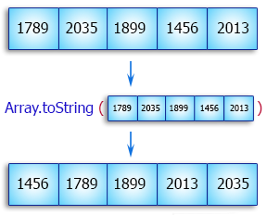

1. **Write a Java program to calculate the average value of array elements.**

**Pictorial Presentation:**

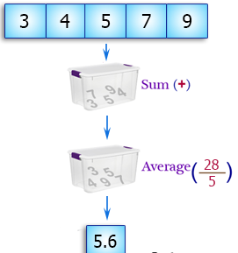

1. **Write a Java program to find the maximum and minimum value of an array.**

**Pictorial Presentation:**

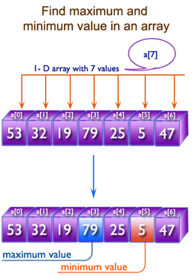

1. **Write a Java program to find the duplicate values of an array of integer values**

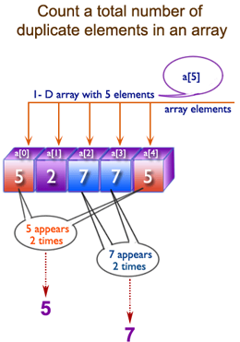

1. **Write a Java program to reverse an array of integer values.**

**Pictorial Presentation:**

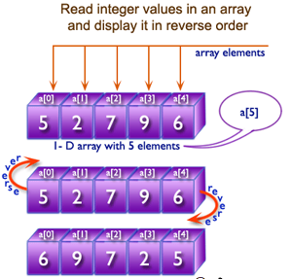

1. **Write a Java program to find the second largest element in an array.**

**Pictorial Presentation:**

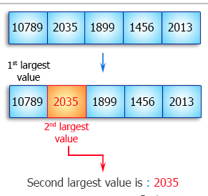

1. **Write a Java program to find all pairs of elements in an array whose sum is equal to a specified number.**

**Pictorial Presentation:**

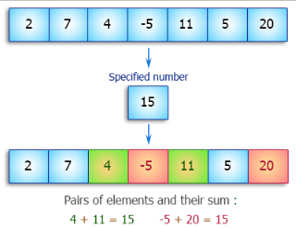

1. **Write a Java program to test the equality of two arrays.**

**Pictorial Presentation:**

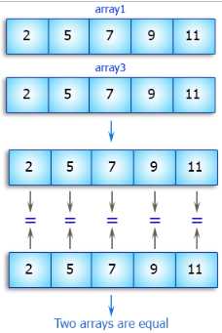

1. **Write a Java program to convert an ArrayList to an array.**

**Pictorial Presentation:**

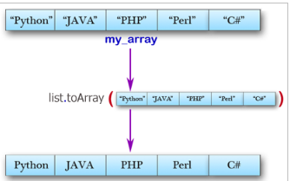

1. **Write a Java program to find a missing number in an array.**

**Pictorial Presentation:**

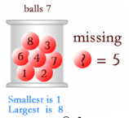

1. **Write a Java program to find common elements from three sorted (in non-decreasing order) arrays.**

**Pictorial Presentation:**

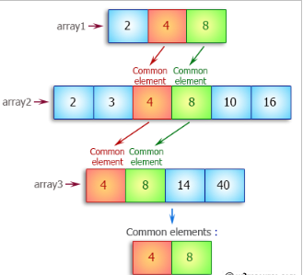

1. **Write a Java program to check if an array of integers without 0 and -1.**

**Pictorial Presentation:**

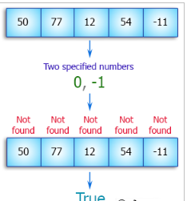

1. **Write a Java program to find the sum of the two elements of a given array which is equal to a given integer.  
   Sample array: [1,2,4,5,6]  
   Target value: 6.**

**Pictorial Presentation:**

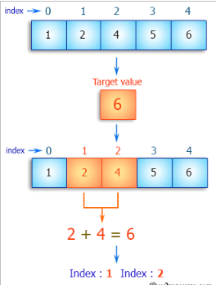

1. **Write a Java program to find all the unique triplets such that sum of all the three elements [x, y, z (x ≤ y ≤ z)] equal to a specified number.  
   Sample array: [1, -2, 0, 5, -1, -4]  
   Target value: 2.**

**Pictorial Presentation:**

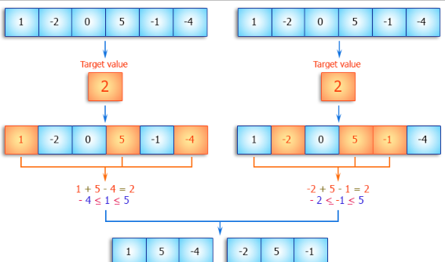

1. **Write a Java program to find the two elements from a given array of positive and negative numbers such that their sum is closest to zero.**